Game Design Document

Fill up the following document

1. Write the title of your project.

The Archery Game

1. What is the goal of the game?

The player will have to hit the bull’s eye to score maximum points.

1. Write a brief story of your game.

The game consists of an archer, bow and an arrow. Archer will have to hit the bull’s eye to score maximum points. If he hits any other region then he will score lesser points.

1. Which are the playing characters of this game?

* Playing characters are the ones who respond to the user based on the input from the user.
* Cars, monkeys, dinos, wizards, etc., are the playing characters in the game.

|  |  |  |
| --- | --- | --- |
| Number | Character Name | What can this character do? |
| 1 | Player 1 | He hits the bull’s eye with his bow and arrow. |
| 2 | Computer 1 | He hits the bull’s eye with his bow and arrow |

1. Which are the Non-Playing Characters of this game?

* Non-Playing characters are the ones that don't have an action or behavior when the user interacts with the game.
* Hurdles, stones, bananas, coins, etc., are non-playing characters in the game.

|  |  |  |
| --- | --- | --- |
| Number | Character Name | What can this character do? |
| 1 | Archer board | NA |

Draw your imagination of this game. What does this game look like?

* Draw the game either on your computer or on paper.
* Add images of the game scenes to show each of the playing and non-playing characters at least once.



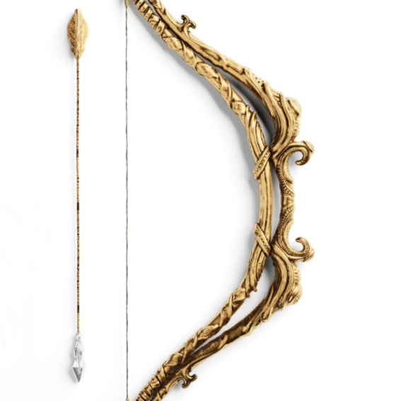

How do you plan to make your game engaging?

Whenevr the archer hits the bull’s eye then he recieves a text saying “Good Job Champ!” and if the archer doenot hit he bull’s eye then he recieves a message saying Better Luck Next Time Champ.